Michael Liam Sinclair

Professor Davis

CSCI 412

November 10, 2023

Software-Defined Networking

Software-defined networking, or SDN, is an innovative approach to network management that employs software such as application programming interfaces, or APIs, and software-based controllers to control network traffic as well as create virtual networks. This paper will explore the advantages and disadvantages of SDN, security concerns, and emphasize its significance in modern networking.

Software-defined networking (SDN) stands out as a transformative approach in networking, using software-based controllers or APIs to communicate with hardware infrastructure and manage network traffic. Unlike traditional networking that relies on dedicated hardware for control, SDN enables the creation and management of virtual networks through software. This enhances network flexibility and simplifies network administration (VMware). The core components of SDN include a centralized controller that manages network resources, automation, and policy enforcement, along with Southbound and Northbound APIs facilitating communication between the controller and network devices (Cisco).

SDN applications play a pivotal role in SDN, utilizing the SDN controller to relay actions and request resources, offering services such as network management, analytics, and security. These applications establish a new environment where software dictates hardware behavior, making SDN more adaptable and responsive (Nutanix).

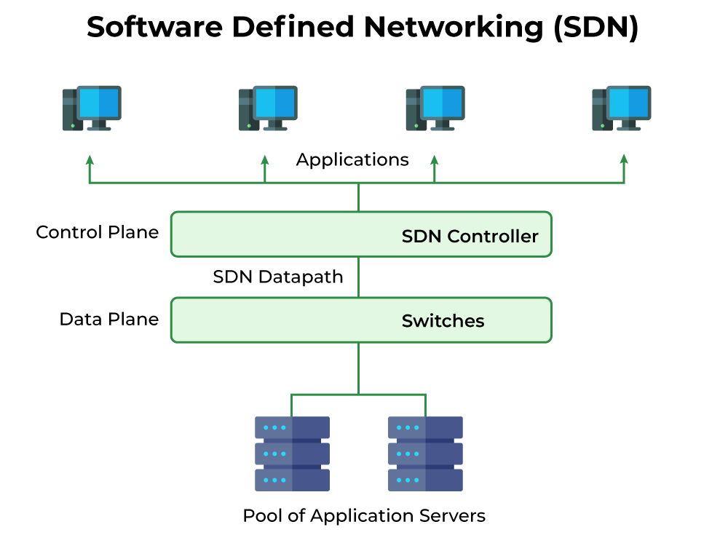

Fig. 1. Pictured above is a high-level overview of SDN architecture, with the control and data plane shown to be decoupled. Application servers are treated as a pool of resources that the virtual network may dynamically pull from to carry out its operations (De).

Network virtualization is a key aspect of SDN, decoupling network services from underlying hardware, allowing for the provisioning of an entire virtual network. Physical network components are abstracted into software, requiring only IP packet forwarding from the hardware. Network and security services become distributable, enabling the segmentation of virtual networks within a single physical network, and connecting devices across different physical networks. This approach changes how data packets are routed, moving the control from hardware to centralized servers. Network services and security policies are dynamically applied to virtualized workloads, ensuring consistency as workloads move across hosts. An example of network virtualization is Virtual LAN (VLAN), which combines network devices into a group, enhancing network performance and simplifying network management (VMware).

SDN utilizes programmable open-source networking protocols, like OpenFlow, to manage and monitor data and network traffic within the SDN network. This is achieved through Northbound and Southbound interfaces, where Northbound interfaces communicate between the controller and applications, while Southbound interfaces facilitate communication between the controller and physical network hardware (Nutanix).

The separation between the control plane and the data plane is a fundamental feature of SDN, offering greater flexibility. The control plane makes decisions about data routing, while the data plane physically moves data packets. A simple example illustrates the process: a data packet is sent from an application, and the SDN controller instructs a switch on where to send the data. The switch forwards the packet and reports back to the controller, updating it on each operation (Nutanix). SDN supports dynamic routing, allowing switches to request instructions from the controller when they receive data packets without routing instructions (VMWare).

SDN serves various purposes, supporting DevOps, application updates, deployment, and IT infrastructure improvements. It enhances the functionality of complex networks, including campus networks, by providing higher automation and centralized management. SDN also facilitates the creation of distributed firewall systems via virtualization, enhancing security (Nutanix). It can build programmable networks that auto-discover and auto-configure switches and devices (Cisco). Moreover, network virtualization contributes to Software-as-a-Service (SaaS), Infrastructure-as-a-Service (IaaS), and other cloud computing services, making SDN an essential tool for efficiently controlling network traffic and scaling as needed (IBM).

There are four main types of SDN, Open SDN, API-based SDN, the overlay model, and hybrid SDN. Open SDN relies on protocols like OpenFlow to control the behavior of virtual and physical switches at the data plane level (VMWare). It offers a more straightforward approach to SDN, with OpenFlow acting as a southbound protocol communicating with network switches. The controller gathers information from applications and converts it into flow entries transmitted to switches via OpenFlow (Nutanix).

OpenFlow Logical Switches contain flow tables and group tables that handle packet lookups and forwarding. These switches connect with the controller through OpenFlow channels, creating centralized control over network devices. Flow entries can be created reactively or proactively. Reactive entries are generated as the controller learns the topology and devices' locations, while proactive entries are programmed before packets arrive, facilitating end-to-end connectivity (Donato). Open SDN provides organizations with centralized control over all switches and data movement throughout the network, regardless of whether the switches are virtual or physical (Nutanix).

API-based SDN relies on programming interfaces (southbound APIs) to monitor and control network traffic through switches and hardware. This approach does not require OpenFlow but instead leverages traditional network methods such as SNMP, CLI, or REST APIs. Devices receive control points allowing remote operation by the controller. API-based SDN is well-suited for traditional switches, providing openness and requiring fewer proprietary devices or software (Nutanix).

The overlay model involves a virtual network layered on top of existing hardware, with channels facilitating data movement between data centers (Nutanix). This model provides tunnels containing channels for interconnecting data centers, allocating bandwidth and assigning devices to channels (IBM). Notably, the physical network remains unchanged, as a hypervisor serves as the interface between physical devices and the virtual network (VMWare). The hypervisor isolates the hypervisor operating system from virtual machines, treating resources such as CPU, memory, and storage as a pool that can be allocated to virtual machines (Red Hat). Only physical devices at the edge of the virtual network are connected, and the hypervisor repackages data received by these devices into frames according to the controller's instructions (Nutanix).

Fig. 2. Pictured above is an example overlay model setup where an OSPF network is split into different parts connected by SDN nodes. When the network changes, traditional routers update their routing tables, and SDN nodes pass this information to a controller. The controller optimizes routing settings for load balancing in each network part, and these settings are then applied through SDN nodes at the edges of each part (Khorsandroo et al.).

Hybrid SDN combines SDN and traditional networking, optimally assigning protocols for different types of traffic. This approach is often adopted incrementally, allowing network administrators to introduce SDN into legacy environments gradually (IBM). It supports various network topologies like VPN, MPLS, and Ethernet, offering flexibility for organizations with unique needs. However, it increases complexity and demands advanced management and troubleshooting skills (Nutanix).

Both SDN and traditional networking provide network connectivity and employ standard networking protocols such as TCP/IP and Ethernet. They share security concerns related to unauthorized access and cyberattacks and offer quality of service (QoS) to ensure critical applications receive the necessary bandwidth and resources (Satyabrata). Unlike traditional networks, SDN offers centralized intelligence that simplifies the establishment and enforcement of security policies, ensuring universal compliance across the network. The abstraction layer between software and hardware allows teams to develop security tools and implement them network-wide, bypassing the need for proprietary devices. This scalability advantage stems from SDN's independence from expensive hardware, enabling the creation, control, and deployment of security policies at scale as the software evolves (Nutanix).

Moreover, SDN introduces a significant shift in security dynamics. Since it allows for the bypassing of proprietary devices, teams may immediately develop security tools. This contrasts with traditional networks, which rely heavily on proprietary hardware for security. With SDN, security measures become adaptable and dynamic, scaling effortlessly with evolving network requirements (Nutanix). Additionally, SDN promotes the establishment of consistent zero-trust access across the network through policy-based segmentation. This approach ensures that security measures are applied based on workload type or network segments, enhancing overall network security (Cisco). SDN grants centralized administrative control, enabling higher levels of reactivity, threat detection, and overall control. Administrators can manage the network, configure settings, provision resources, and expand network capacity—all from a centralized user interface without the need for additional hardware (VMware).

SDN as a new approach to networking offers a great deal of benefits, of which visibility stands out. SDN offers a comprehensive view of the entire network through a centralized source, streamlining management and provisioning. This visibility is crucial for optimizing network performance and troubleshooting. SDN also leads to significantly lower operating expenses and improved resource and server utilization. This results in a higher return on investment (ROI) and reduces the total cost of ownership (TCO) over the network's lifecycle (Nutanix).

Businesses can leverage SDN to create a central cloud that consolidates all components of their infrastructure. This unification simplifies network management and enhances overall operational efficiency (Nutanix). SDN facilitates the seamless movement of data between distributed locations, a crucial requirement for cloud applications. This capability is instrumental in enabling cloud services to function optimally (VMware). Additionally, SDN empowers DevOps teams by allowing them to redirect and manipulate data traffic, improving service delivery and network responsiveness. This capability enhances the agility and efficiency of development and deployment processes (Nutanix).

SDN creates telecommunications optimizations, as network functions virtualization (NFV) within SDN enables telecommunications providers to shift customer services to less costly servers. This flexibility allows service providers to move workloads between private and public cloud infrastructures, ensuring immediate availability of new customer services. SDN simplifies the process of adding or removing virtual machines, making networks highly adaptable to changing demands. This scalability ensures that networks can grow, or contract as needed without significant reconfiguration (VMware).

The speed and flexibility of SDN make it an ideal framework for supporting emerging technologies like edge computing and the Internet of Things (IoT). These technologies rely on rapid and efficient data transfer between distributed locations, a capability inherent to SDN (VMware). SDN enables dynamic load balancing, allowing network administrators to manage and control data traffic flow as needed. This agility reduces latency and ensures optimal use of network resources. These advantages of SDN additionally allow for it to be leveraged through SD-WAN (Software-Defined Wide Area Networking) as a powerful alternative to traditional WAN solutions. SD-WAN programmatically configures and centrally manages network topology, handling large volumes of traffic and multiple connectivity types (IBM). SD-WAN optimizes routing configurations, lowers operational and capital expenses, improves network agility, and supports multiple secure connections (Juniper Networks).

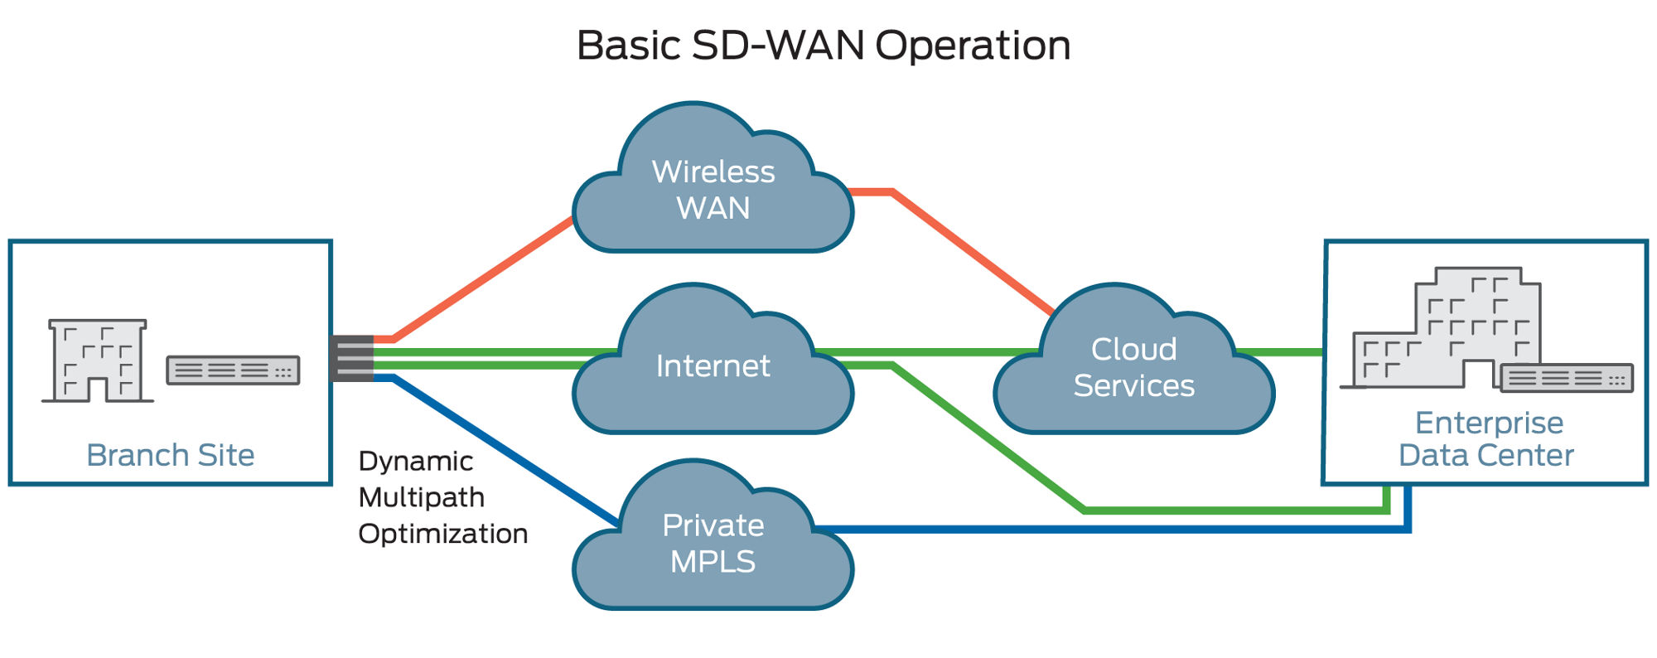

Fig. 3. Pictured above is a high-level overview of a basic SD-WAN operation. SD-WAN is a smart and automated wide-area network that dynamically directs and secures traffic based on application rules, network conditions, or priority of the wide-area network circuit (Juniper Networks).

SDN empowers network administrators to set security policies from a centralized location, ensuring consistent enforcement network-wide. Security measures can be tailored based on workload type or specific network segments, enhancing overall network security (IBM). Although the centralized nature of SDN enhances security policy management, it introduces a single point of failure—the controller. This vulnerability necessitates robust security measures to safeguard the controller from unauthorized access and control (VMware). To mitigate this risk, redundancy measures must be implemented, including controller redundancy with automatic failover. Although this approach may incur additional costs, it is a standard practice in network design to ensure business continuity (IBM).

Moreover, the control plane layer is susceptible to Distributed Denial-of-Service (DDoS) attacks, where SDN switches inundate the controller with an excessive volume of requests, potentially causing delays or dropped requests. Implementing multiple physical SDN controllers can distribute the load and reduce the risk of overload on a single controller. Additionally, to protect against interception during data transfer, encryption with digital signatures is crucial for securing and authenticating messages. The most critical vulnerability lies in malicious access to the SDN controller, potentially compromising the entire network. To mitigate this risk, rigorous security coding practices, comprehensive change management, and integrity checks within the software development lifecycle are imperative (Fruhlinger).

Performance is a paramount concern for any network, including SDN. The separation of the control and data planes can introduce latency, especially in large networks. Controller response time and throughput also influence network performance and scalability. To address this, one potential solution is to push more intelligence to the data plane or shift towards a distributed control plane architecture. This approach may improve performance but necessitates a careful balance to maintain virtualization without sacrificing network performance or creating a single point of failure (Saraswat et al.).

In conclusion, Software-Defined Networking (SDN) represents a significant advancement in network management and control. It leverages software-based controllers and APIs to revolutionize how network traffic is managed and virtual networks are created. SDN offers a range of benefits, including enhanced visibility, lower operating expenses, unification of network components, and support for emerging technologies. However, it also comes with security challenges and potential latency issues, requiring careful implementation and management.

**Works Cited**

Cisco. “Software-Defined Networking.” *Cisco*, 2023, www.cisco.com/c/en/us/solutions/software-defined-networking/overview.html#~what-is-sdn. Accessed 10 Nov. 2023.

De, Abhishek. “Software Defined Networking.” *GeeksforGeeks*, 8 May 2023, www.geeksforgeeks.org/software-defined-networking/. Accessed 10 Nov. 2023.

Donato, Rick. “What Is OpenFlow?” *Fir3net*, 2023, fir3net.com/Networking/Protocols/what-is-openflow.html. Accessed 10 Nov. 2023.

Fruhlinger, Josh. “What Is SDN and Where Is It Going?” *Network World*, 6 June 2023, www.networkworld.com/article/3209131/what-sdn-is-and-where-its-going.html. Accessed 10 Nov. 2023.

Satyabrata, Jena. “Difference between Software Defined Network and Traditional Network.” *GeeksforGeeks*, 18 Aug. 2020, www.geeksforgeeks.org/difference-between-software-defined-network-and-traditional-network/#. Accessed 10 Nov. 2023.

IBM. “What Is Software-Defined Networking?” *Www.ibm.com*, 2023, www.ibm.com/topics/sdn. Accessed 10 Nov. 2023.

Juniper Networks. “What Is SD-WAN (Software-Defined Wide-Area Network)? | Juniper Networks.” *Juniper Networks*, 2023, www.juniper.net/us/en/research-topics/what-is-sd-wan.html. Accessed 10 Nov. 2023.

Khorsandroo, Sajad, et al. “Hybrid SDN Evolution: A Comprehensive Survey of the State-of-The-Art.” *Computer Networks*, vol. 192, 19 Feb. 2021, www.sciencedirect.com/science/article/pii/S1389128621001109, https://doi.org/10.1016/j.comnet.2021.107981. Accessed 10 Nov. 2023.

Nutanix. “What Is Software-Defined Networking (SDN)?” *Nutanix*, 19 Sept. 2023, www.nutanix.com/info/software-defined-networking#howworks. Accessed 10 Nov. 2023.

Red Hat. “What Is a Hypervisor?” *Red Hat*, 3 Jan. 2023, www.redhat.com/en/topics/virtualization/what-is-a-hypervisor. Accessed 10 Nov. 2023.

Saraswat, Surbhi, et al. “Challenges and Solutions in Software Defined Networking: A Survey.” *Journal of Network and Computer Applications*, vol. 141, 1 Sept. 2019, pp. 23–58, doi.org/10.1016/j.jnca.2019.04.020, https://doi.org/10.1016/j.jnca.2019.04.020. Accessed 10 Nov. 2023.

VMWare. “What Is Software-Defined Networking (SDN)?” *VMWare*, 2023, www.vmware.com/content/vmware/vmware-published-sites/us/topics/glossary/content/software-defined-networking.html.html. Accessed 10 Nov. 2023.

VMware. “What Is Network Virtualization? | VMware Glossary.” *VMware*, 17 Dec. 2021, www.vmware.com/topics/glossary/content/network-virtualization.html. Accessed 10 Nov. 2023.